Chapter 11, Solution 56.

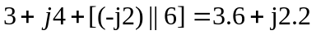

The circuit is reduced to that shown below.
5 
230 A
I_{o}
+
V_{o}
−
3.6 + j2.2 

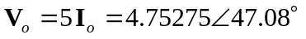

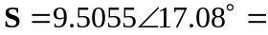(9.086+j2.792) VA

